HTML SCENARIO QUESTIONS

- Mandatory Multi-Field Validation
A registration form has username, email, and password. Ensure that all three fields are required. The username must be at least 5 characters, and the password at least 8 characters. Question: How will you enforce this using HTML5 validation?
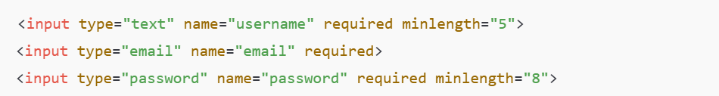

- Conditional Validation
You have a checkbox “Subscribe to newsletter”. If checked, an email field becomes mandatory. Question: Can HTML5 alone enforce conditional required fields? If not, explain why and suggest a solution.
No, HTML5 validation attributes are static and cannot change based on another field’s state.
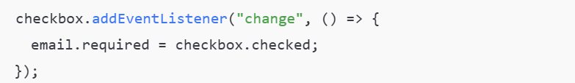

- Numeric Range Edge Cases
A form collects age (number input) with min=18 and max=60. Question: What happens if the user manually enters 0, 61, or 18.5? How will HTML5 validation handle decimals in integer-only scenarios?
HTML5 does not restrict integers only unless:
- Pattern Matching Challenge
You need a phone number input that only allows 10 digits starting with 7, 8, or 9. Question: Write the pattern attribute and explain what happens if someone enters 1234567890.
If user enters 1234567890 it will be invalid — fails because it does not start with 7, 8, or 9.

- Email Format Traps
A form asks for email with type="email". Question: Will the browser accept “user@@example.com”, “user@com”, or “user@example.co.in”? Explain HTML5 email validation behavior.
Email | Accepted or not | Reason
user@@example.com | No | Double @ is invalid
user@com | No | Domain incomplete
user@example.co.in | Yes | Valid format
HTML5 checks basic syntax, not real existence.

- Textarea Minimum Length
You have a textarea for comments with minlength="50". Question: What happens if a user pastes exactly 50 characters? What about 49 characters? How does the browser handle this?
- Exactly 50 characters → Valid
- 49 characters → Invalid, submission blocked
The browser counts characters automatically.

- Password Complexity
A password field requires: Minimum 8 characters At least one uppercase, one lowercase, one number, and one special character Question: Can HTML5 alone enforce all these rules? If not, which attribute can partially handle it, and what is missing?
- User-friendly error messages
- Dynamic feedback
- Password strength indicators
JavaScript is required

- Real-Time Error Handling
A form has type="number" for quantity with min=1, max=10. Question: If a user types 15 and immediately deletes it, what is the behavior? How do HTML5 and JavaScript differ in real-time error handling?
HTML5 Behavior
- Validation triggers only on form submission
- Temporary invalid values are allowed while typing
JavaScript Difference
JavaScript can:
- Detect invalid input while typing
- Show instant error messages
- Prevent invalid keystrokes

- Multiple Inputs With Same Name
You have 3 checkboxes for hobbies: Music, Reading, Travel. All checkboxes have the same name="hobby" Question: How can you make at least one checkbox required using HTML5?
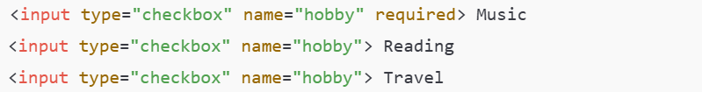

10.Custom Validation Message
You want a custom message for an email field: Default error: “Please enter a valid email” Custom message: “Enter your official email” Question: How do you achieve this using HTML5 or JavaScript?
HTML5 alone cannot change default messages.
JavaScript allows custom error text.

11. URL Input Validation
You have type="url" for website links. Question: Will the browser accept “www.example.com” without https://? Explain HTML5 URL validation behavior.
HTML5 requires a protocol (http:// or https://).

12.Handling Optional Fields
You have a comment field which is optional but if filled, must be at least 20 characters. Question: How do you implement this in HTML5 without using JavaScript?
- Empty field → Allowed
- Filled but less than 20 characters → Invalid
- No JavaScript needed
13. Cross-Field Validation
You have Password and Confirm Password fields. Question: Can HTML5 alone ensure both match? If not, explain what is required.
No, HTML5 cannot compare values between two fields.
Use JavaScript to compare password and confirm password values.

14. Date Input Validation
You have type="date" for event registration. The date must be after today. Question: How can you enforce this using HTML5 attributes? What if the user manually types yesterday’s date?
- Past date entered manually → Invalid
- Browser blocks submission automatically
HTML5 validates even manually typed values.

15.Error Handling UX
You want users to see errors next to fields instead of default browser popups. Question: Can HTML5 alone achieve inline error messages? Explain how JavaScript is needed for custom error placement.
No, HTML5 shows browser-controlled popups only.
JavaScript Role
- Capture validation errors
- Display messages beside fields
- Fully customize user experience

